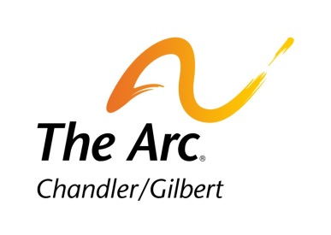

Title VI Complaint Procedures

Any person who believes that he or she has been excluded from participation in, been denied the benefits of, or otherwise subjected to unlawful discrimination under any Chandler/Gilbert Arc service, program, or activity, and believes the discrimination is based upon race, color, or national origin may file a formal complaint with the Chandler/Gilbert Arc Title VI Coordinator. This anti-discrimination protection also extends to the activities and programs of Chandler/Gilbert Arc’s third party contractors. Any such complaint must be filled with 180 days of the alleged discriminatory act (or latest occurrence).

Passengers using federally funded public transportation are entitled to equal access, seating, and treatment. Under Title VI of the Civil Rights Act of 1964 (as amended) and related statutes, Chandler/Gilbert Arc must ensure that no person shall, on the grounds of race, color, or national origin, be excluded from participation in, be denied the benefits of, or be subjected to discrimination under any federally funded program, activity, or service it administers.

Complaints for alleged non-compliance with Title VI and related statutes may be lodged with the Chandler/Gilbert Arc Title VI Coordinator. Any such complaint must be filed within 180 days of the alleged discriminatory act (or latest occurrence). To submit a claim to Chandler/Gilbert Arc by mail or in person, please visit our website at http://www.cgarc.org, print and complete the Title VI Complaint Form, and deliver or mail to: Chandler/Gilbert Arc Attention: Title VI Coordinator 3250 N. San Marcos Pl. Chandler, Arizona 85225

