Chandler Gilbert Arc

ADA Complaint Procedure and Forms (English and Spanish)

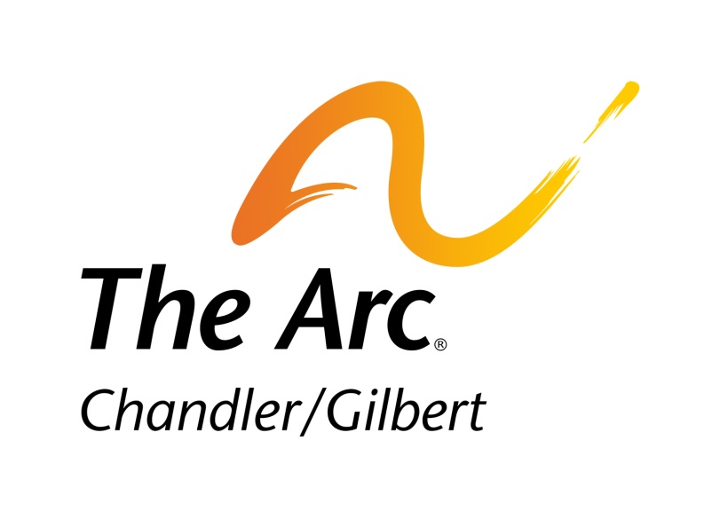

Developed 7-2019

ADA-Related Service Complaint Process

(Developed 7-2019)

Chandler Gilbert Arc welcomes comments, complements, and complaints from customers on their experiences using Chandler Gilbert Arc’s services. Customer input helps us identify areas needing improvement, and commendations are always appreciated. Whether our customers are submitting complaints about service problems or sharing a great experience, we welcome the opportunity to be of service
All customer complaints are carefully reviewed, and those submitted by customers who experience accessibility or ADA-related problems are additionally reviewed for adherence to Chandler Gilbert Arc policies by the Chandler Gilbert Arc HR representative
To file an ADA-related service complaint, customers may contact Chandler Gilbert Arc using any of the following methods:

Via Mail to:
Chandler Gilbert Arc
c/o Human Resources Department
3250 N. San Marcos Place
Chandler, AZ 85225

Via Phone
480-892-9422

Via Website
www.cgarc.org

Via Email
hr@cgarc.org
Chandler Gilbert Arc will investigate the complaint and promptly communicate a response to the customer with 10 business days.

All submittal methods will result in the Customer Relations department receiving the complaint information and entering it into the customer comment information folder, which documents every complaint received and all related follow-up activities. Customers with an ADA-related complaint will receive a complaint confirmation/tracking reference number, usually within the same day but no later than ten (10) business days from the day Chandler Gilbert Arc receives the complaint. If the customer does not receive a response within the ten (10) day timeframe, he or she can call the Human Resources Department Representative Department at the number listed above to obtain status update of the claim
Responsible Chandler Gilbert Arc operating divisions or administrative departments investigate all complaints and implement any corrective actions to be taken. Complaints involving ADA or accessibility elements receive an additional review by HR Generalist after the investigation has been completed. After the ADA Compliance oversight review has been completed, Customer Relations will provide a written reply to the complainant at the contact address provided within ninety (90) days of receiving the complaint. All complaints are investigated within a few weeks, but some may require more extensive investigation, or require more time to identify corrective measures. In any case, a written reply will be provided to the customer within ninety (90) days.

Chandler Gilbert Arc

Americans with Disabilities Act and
Section 504 of the Rehabilitation Act of 1973 Discrimination Complaint Form
Instructions: If you believe Chandler Gilbert Arc has engaged in discrimination against one or more persons based on medical condition or disability, please fill out this form completely, sign, and return to the address on the next page.

Alternative means of filing complaints, such as personal interviews or a tape recording of the complaint will be made available for persons with disabilities upon request. Call
480-892-9422 for assistance

Name of Complainant:

Address: City: State: Zip Code:
Home Phone: Business Phone:

Person Discriminated Against:
(if other than the complainant)

Address: City: State: Zip Code:
Home Phone: Business Phone:

What date did the discrimination occur?

Describe the acts of discrimination providing the name(s) where possible of the individuals who discriminated (use additional space on the next page if necessary):

Has a complaint been filed with another bureau of the Department of Justice or any other Federal, State, or local civil rights agency or court? Yes ◻ No ◻

If yes, Agency or Court:

Contact Person:

Address:

City: State: Zip Code:

Phone Number:

Date Filed:

Additional space for answers:

Signature: Date:

Please Return Form to:

HR Generalist

Chandler Gilbert Arc
3250 N. San Marcos Place
Chandler, AZ 85225

Or by email at Type hr@cgarc.org

Phone: (480) 892-9422
Fax: (480) 497-0657

Chandler Gilbert Arc

Formulario de reclamo por discriminación de la Ley de Estadounidenses con Discapacidades (ADA) y Sección 504 de la Ley de Rehabilitación de 1973
Instrucciones: Si usted considera que la Chandler Gilbert Arc por sus siglas en inglés) cometió discriminación en contra de una o más personas, en base a una enfermedad o discapacidad, por favor llene este formulario por completo, fírmelo y envíelo a la dirección que aparece en la siguiente página.

Otros medios para presentar reclamos, como por ejemplo entrevistas personales o una grabación del reclamo, estarán disponibles para las personas con discapacidades, a petición previa. Para obtener asistencia, llame al 480-892-9422

Nombre del demandante:

Dirección:

Ciudad: Estado: Código postal:

Teléfono residencia: Teléfono trabajo:

Nombre de la víctima de discriminación:
(Si es distinto al del demandante)

Dirección:

Ciudad: Estado: Código postal:

Teléfono residencia: Teléfono trabajo:

¿En qué fecha ocurrió el acto de discriminación?

Describa los actos de discriminación, suministrando el (los) nombre(s), de ser posible, de los individuos responsables de los actos discriminatorios (use el espacio adicional en la siguiente página de ser necesario):

¿Se presentó el reclamo ante otra oficina del Ministerio de Justicia o algún tribunal u organismo de derechos civiles federal, estatal o local? Sí ◻ No ◻

En caso afirmativo, indique organismo o tribunal:

Persona de contacto:

Dirección:

Ciudad: Estado: Código postal:

Teléfono:

Fecha de presentación del reclamo:

Espacio adicional para las respuestas:

Firma: Fecha:

Por favor envíe el formulario a:

Chandler Gilbert Arc
3250 N. San Marcos Place
Chandler, AZ 85225
o por correo electrónico a hr@cgarc.org

Teléfono: (480) 892-9422
Fax: (XXX)
TTY: (480) 497-0657

